**Restaurant Management System for ‘The Grill House’**

**SIMPLILEARN PC BA – BUSINESS ANALYST CAPSTONE PROJECT – 1**

Submitted By:

**Rohan Maity**

Table of Contents

Introduction 3

Week 1 & 2 - CBAP 4

1. Business Analysis Core Concept Model (BACCM) 4

2. Stakeholder Identification 6

2.1 Internal and External Stakeholder Classification 6

2.2 Stakeholder Activity Analysis 6

2.3 Stakeholder Onion 8

2.4 RACI Matrix 8

2.5 Stakeholder Matrix 10

3. As-Is and Future State Map 11

3.1 As-Is State 11

3.2 Future State 12

4. Scope of the Restaurant Management Software 13

5. Main Features to be developed 14

6. In-Scope and Out-of-Scope Items 15

7. Requirements of the Business 16

7.1 Functional Requirements 16

7.2 Non-Functional Requirements 16

8. Mock Screens for the Restaurant Management Software 17

Week 3 – Tableau & Excel 19

1. Tableau 19

2. Excel 21

2.1 Question 1 21

2.2 Question 2 23

# Introduction

‘The Grill House’ is a chain of restaurants across all cities in USA and owned by US celebrity chef, James Oliver. He wants to set up a new Restaurant Management System to track the day-to-day management of his restaurants. Currently, they have a paper-based system for the same and this has many issues. The orders were taken by the waiters on paper and a paper-based bill was presented to the customers. All the bills were entered into an excel sheet by the manager at EOD to know the total sales and item-wise sales for the day. Then reports were generated in excel to know trends and details like daily, weekly, and monthly sales as well as which dishes were popular and which weren’t doing so well.

The restaurants need a system that will allow them to easily update their menu. The clients currently do not have a system that recognizes the different types of users such as managers, waiters, etc. and they would like to be able to limit the access of some options of the system to certain users.

# Week 1 & 2 - CBAP

## 1. Business Analysis Core Concept Model (BACCM)

The Business Analysis Core Concept Model or BACCM is a business analysis conceptual framework used to evaluate six core concepts of any given business analysis project or task.

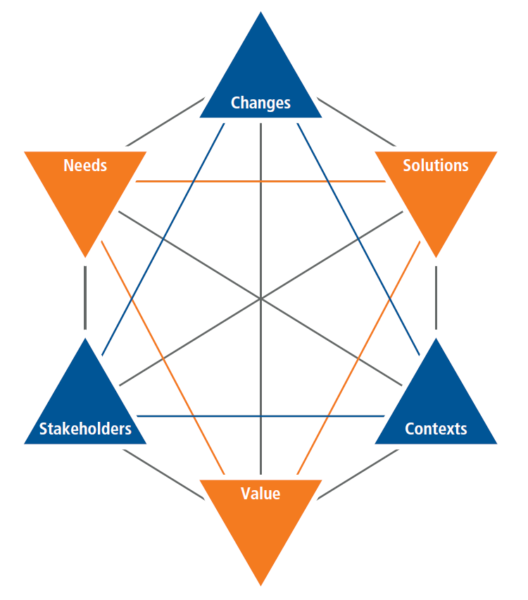

**Figure 1: BACCM Model**

In the context of the Restaurant Management System for ‘The Grill House’, the application of the BACCM model will yield:

|  |  |
| --- | --- |
| **BACCM** | |
| **Need** | * Paper-based management system that takes customer orders and generate bills on paper. * Non-Automated system where data is entered by manager at EOD to know total sales and item sales for restaurants. * Out-dated system for generating trends and details like daily, weekly, and monthly sales as well as popularity of dishes. * Lack of a proper daily menu updating system. * Inability to limit the access of options of the system to certain users. |
| **Context** | * Multiple restaurants for ‘The Grill House’ across different cities in the USA. * James Oliver requiring an automated Restaurant Management System for ‘The Grill House’ replacing their existing paper-based management system. |
| **Change** | * Switching from a traditional paper-based management system to a online-based digital Restaurant Management System that can manage the accessibility and administration tasks on the system for the restaurant staff. |
| **Solution** | * The development of an online-based digital Restaurant Management System that can categorize and update the menu items with price and which can be accessed by the managers only to add new items, delete existing items, as well as create new menus from scratch. * Digital nature of the Restaurant Management System will allow the managers and waiters to search for menu items, generate bills, take orders from the customers, automatically generate management reports on data collected, and take feedbacks. * Table layout will be stored in the system to enable the customers to reserve tables for the restaurant and have payment gateway to allow the customers for payment via cash or card. |
| **Stakeholder** | * **Internal Stakeholders:** Domain SME, Implementation SME, Operational Support, Tester, and Project Manager. * **External Stakeholders:** Customers, Waiters, Restaurant Managers/Management, James Oliver (CEO), Inventory Suppliers, Payroll Administrator (Regulator). * **Business Analyst** |
| **Value** | * Reduction of operating costs of the restaurant. * Efficiency enhancement for restaurant operations. * Ease and effectiveness of generating management reports. * Increase in productivity as well as profitability for the restaurant. |

**Table 1: BACCM Core Concepts for the Restaurant Management System**

## 2. Stakeholder Identification

### 2.1 Internal and External Stakeholder Classification

The internal and external stakeholders for the Restaurant Management System for ‘The Grill House’ are:

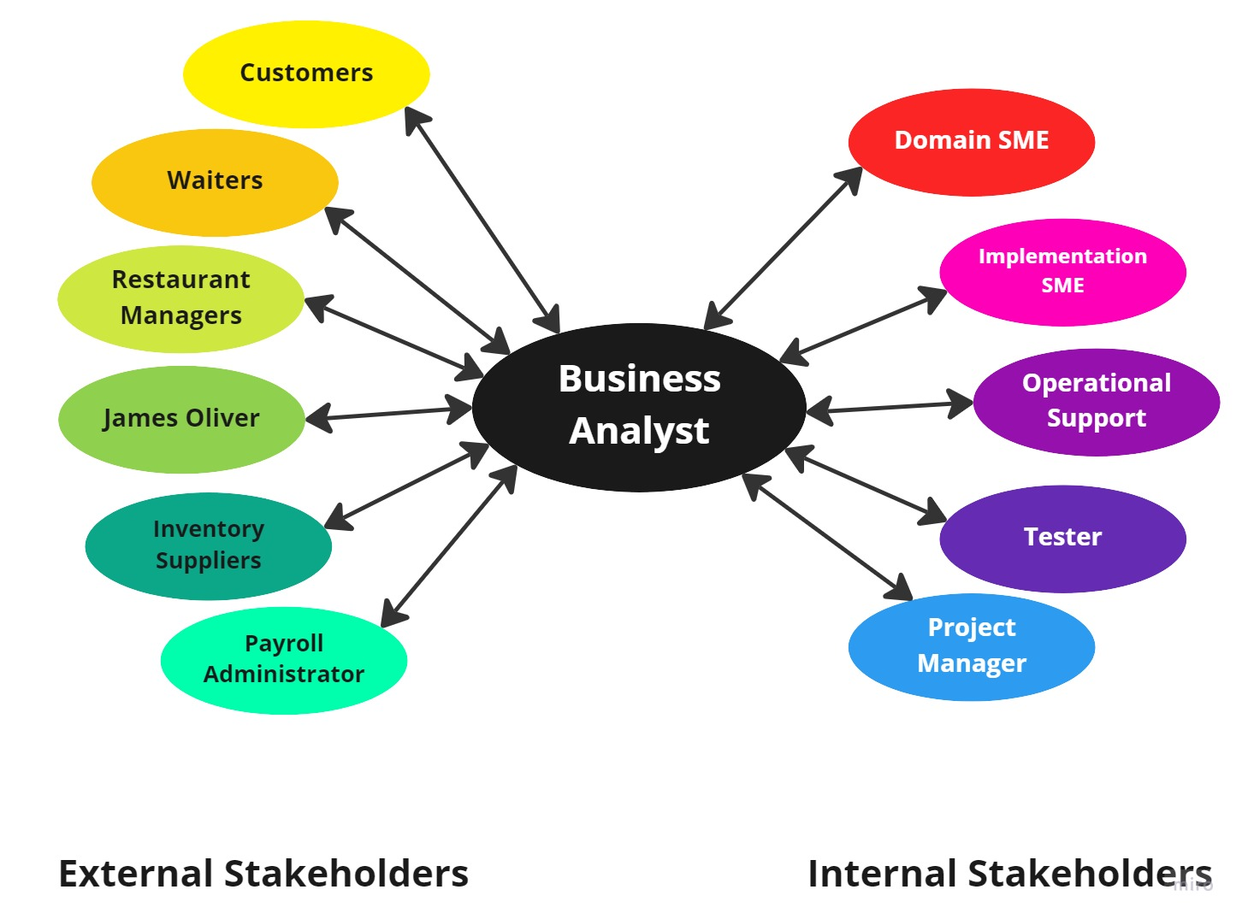

**Figure 2: Stakeholder Classifications**

### 2.2 Stakeholder Activity Analysis

The stakeholders and their activities for the Restaurant Management System for ‘The Grill House’ are:

|  |  |
| --- | --- |
| **Actor** | **What they can do on the Software Created** |
| **Customers** | * Visit the website and place an order for their meals from the menu items available. * Provide information for table reservations such as date, time, and number of people. * Pay through the payment gateway using cash or card. * Provide feedback to the provided feedback form in the system after their meals. |
| **Waiters** | * Search the menu items in the system using search facility. * Look into system to determine which tables need to be reserved. * Take the order of the customers through the system. * Access the software and generate bills for the customers. |
| **Restaurant Managers/Management** | * Create, edit, delete, update, and manage the regular menu items. * Search the menu items in the system using search facility. * Reserve and book tables using the system. * Evaluate automatically generated sales related management reports at the EOD. * Add customer informational manually into the system along with feedbacks from customer. |
| **James Oliver/CEO** | * Assess the feedback from customers given on the system and take suitable actions. * Access the system and evaluate sales related management reports. |
| **Payroll Administrator** | * Account for the monthly salaries of the waiters and the management team. |
| **Inventory Suppliers** | * Takes orders for food ingredients from the restaurant managers and delivers them to the restaurants within the specified date. |
| **Business Analyst** | * Engage with the internal and external stakeholders. * Understand the specific project requirements. * Create BA deliverables and essential documents. |
| **Domain SME** | * Provide inputs on the functional developments of the system. |
| **Implementation SME** | * Take inputs from the internal stakeholders and business analyst. * Develop the restaurant system software application. |
| **Operational Support** | * Provide customer care support for the customers. * Handle user interface (UI) and provide support for back-end development requests. |
| **Tester** | * Perform quality analysis on the system for identifying any bugs or issues. * Verify the functionality of the system before its release for usage. |
| **Project Manager** | * Take actions to help guide the project to completion efficiently and effectively. * Guide the internal stakeholders for the development and successful release of the system. |

**Table 2: Stakeholders and their Activities in the System**

### 2.3 Stakeholder Onion

The Stakeholder Onion is a diagram that helps to highlight the relationship of the stakeholders with the project goals. In the context of the project of the Restaurant Management System for ‘The Grill House’, the Stakeholder Onion will be:

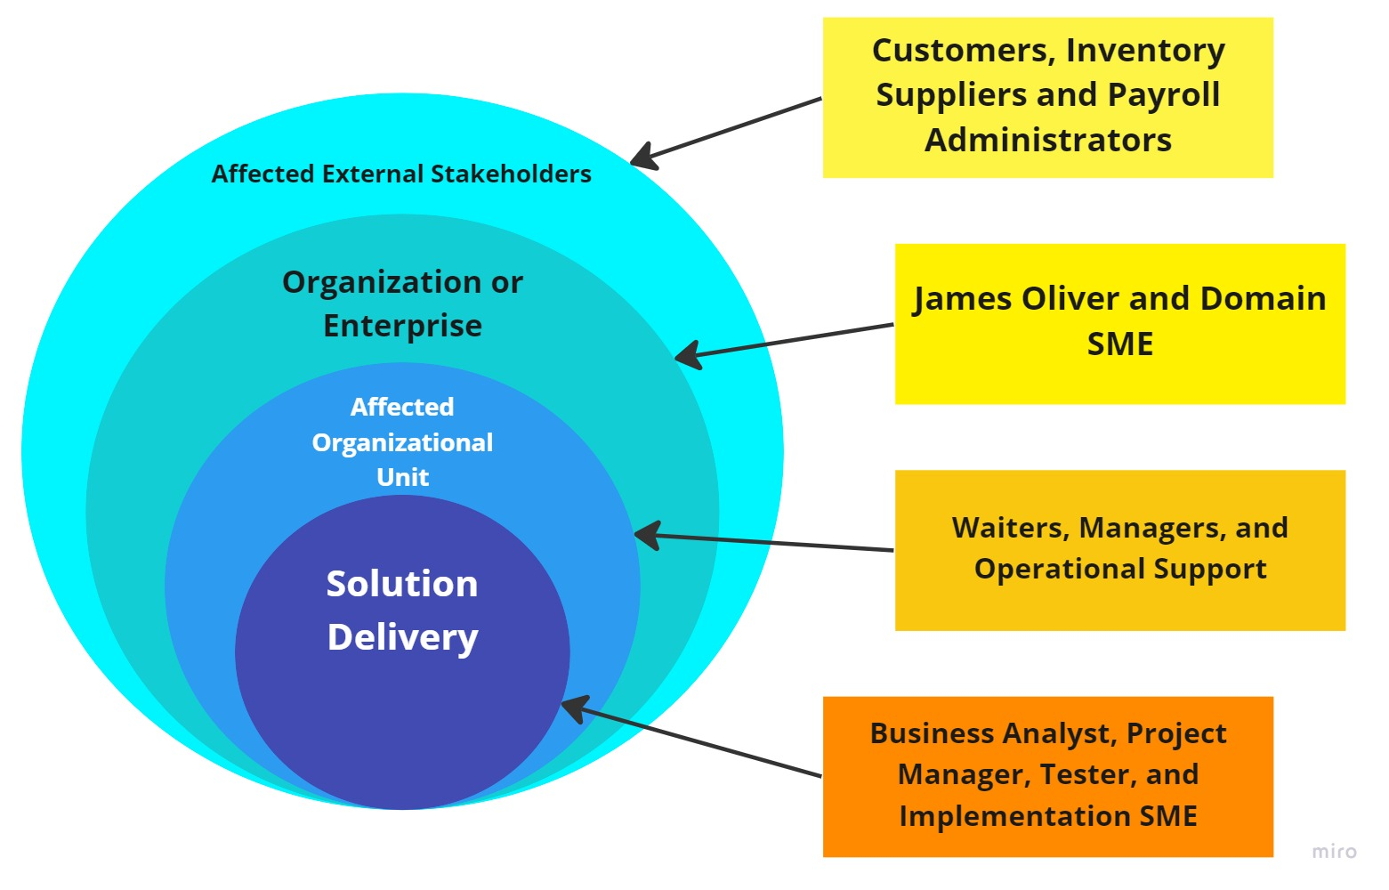

**Figure 3: Stakeholder Onion**

### 2.4 RACI Matrix

The RACI Matrix is a form of stakeholder analysis matrix that categorizes the responsibilities of the stakeholders in a project into 4 different categories. These are:

* **Responsible (R):** The stakeholder who will be performing the work on the task.
* **Accountable (A):** The stakeholder who will be held accountable for the successful completion of the task and is the decision-making individual with only one stakeholder being designated this responsibility type.
* **Consulted (C):** The stakeholder who will be asked for or consulted regarding inputs, opinions, information, and advice on the tasks and is generally designated to the subject matter experts (SMEs).
* **Informed (I):** The stakeholder who will be kept updated or notified of the task and its outcomes where information flows in one way and is different from consulted where information flows two-way.

In the context of the project of the Restaurant Management System for ‘The Grill House’, the RACI Matrix will be:

|  |  |  |  |  |
| --- | --- | --- | --- | --- |
| **Stakeholders** | **Responsible** | **Accountable** | **Consulted** | **Informed** |
| **Customers** |  |  |  | **I** |
| **Waiters** | **R** |  |  | **I** |
| **Restaurant Managers/Management** | **R** |  |  | **I** |
| **James Oliver/CEO** |  |  |  | **I** |
| **Payroll Administrator** |  |  |  | **I** |
| **Inventory Suppliers** |  |  |  | **I** |
| **Business Analyst** | **R** |  |  | **I** |
| **Domain SME** |  |  | **C** |  |
| **Implementation SME** | **R** |  | **C** |  |
| **Operational Support** |  |  | **C** |  |
| **Tester** | **R** |  | **C** | **I** |
| **Project Manager** | **R** | **A** | **C** |  |

**Table 3: RACI Matrix**

### 2.5 Stakeholder Matrix

The stakeholder matrix helps to map the level of stakeholder influence against the level of stakeholder interest. The stakeholder matrix is segregated into 4 quadrants based on the axis of the level of influence and level of impact and these are:

* **High Influence/High Impact:** These stakeholders are to be worked closely with and ensured that they agree with the change while supporting it.
* **High Influence/Low Impact:** These stakeholders are to be engaged and consulted with so that they can be kept satisfied as they have needs that are to be met by the change.
* **Low Influence/High Impact:** These stakeholders are supporters of the change and are to be engaged with for their input and keep them informed about the change.
* **Low Influence/Low Impact:** These stakeholders are kept informed and are monitored as they have no significant influence or impact but should be ensured that their influence does not change.

For the project of the Restaurant Management System for ‘The Grill House’, the Stakeholder Matrix will be:

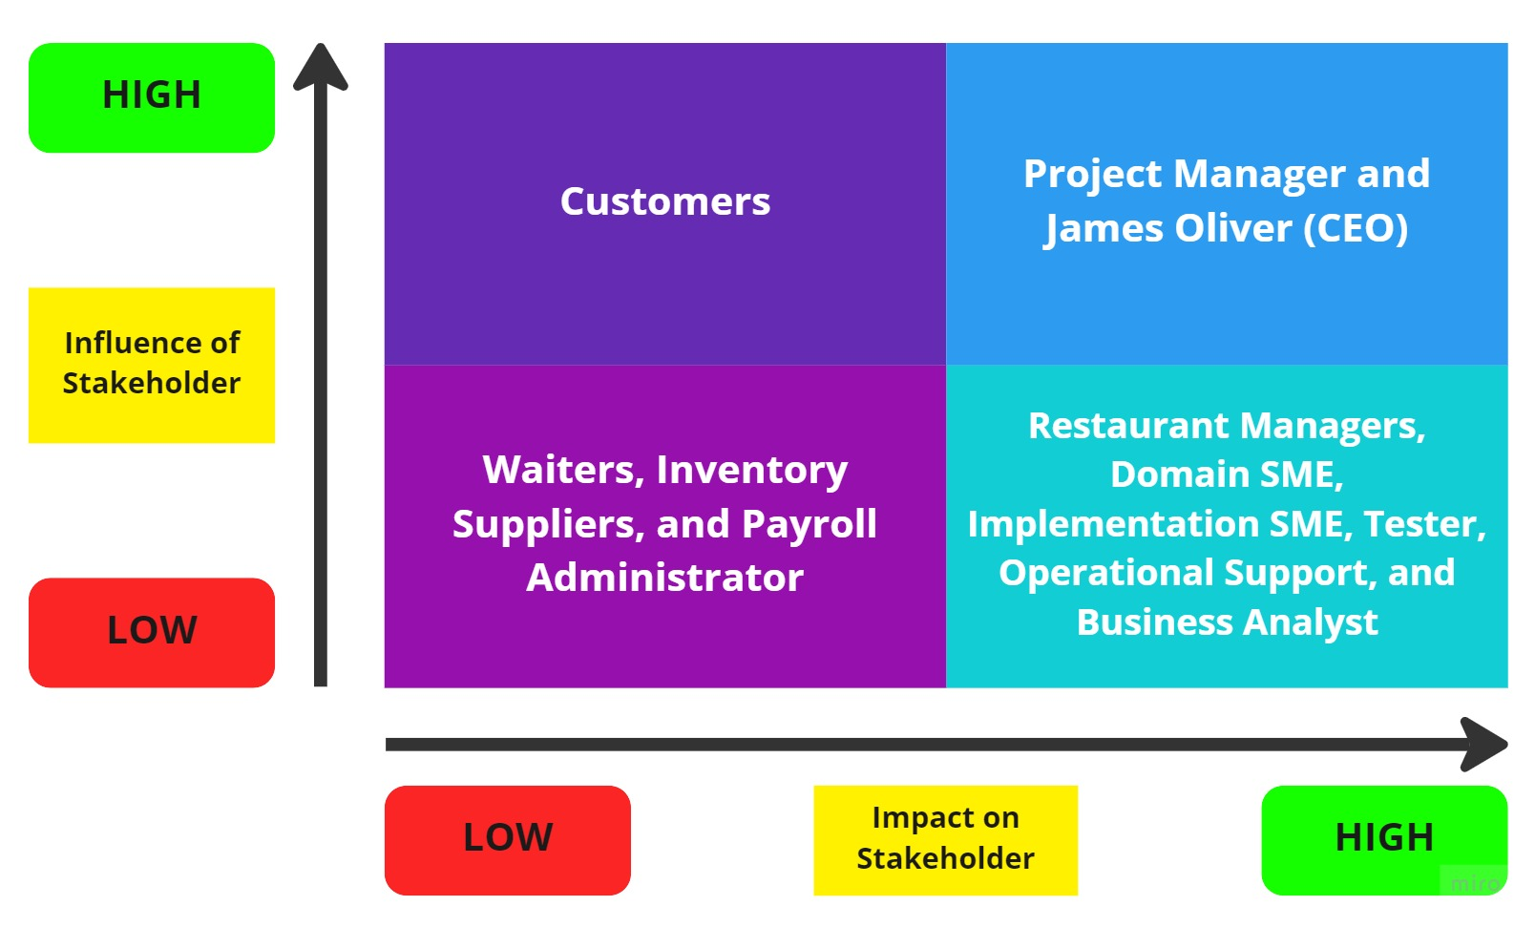

**Figure 4: Stakeholder Matrix**

## 3. As-Is and Future State Map

### 3.1 As-Is State

The current existing state of the restaurant’s management system can be described using this process flow diagram:

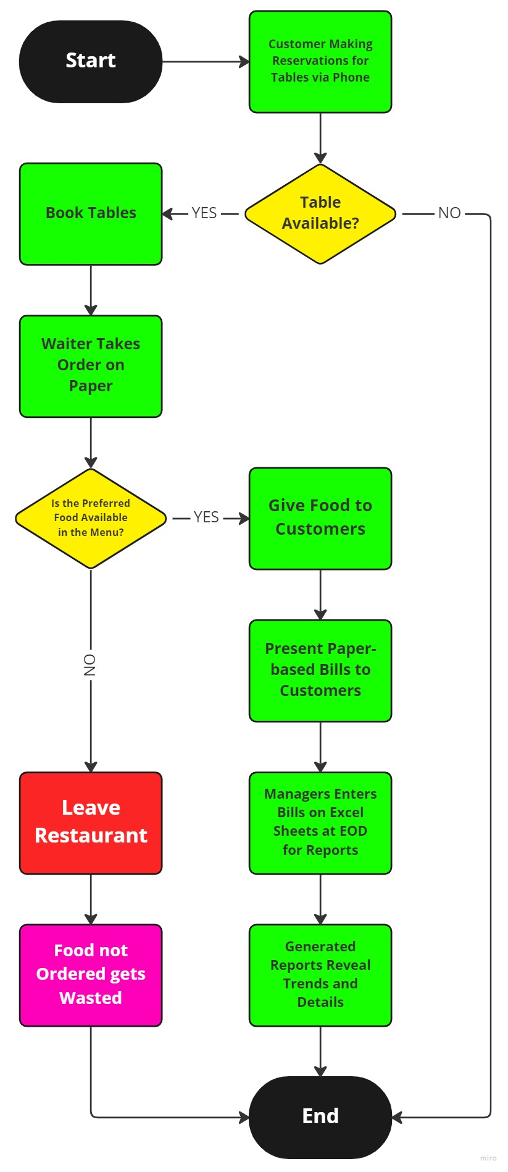

**Figure 5: As-Is State Flow Chart**

### 3.2 Future State

The future state of the Restaurant Management System for ‘The Grill House’ can be described using this process flow diagram:

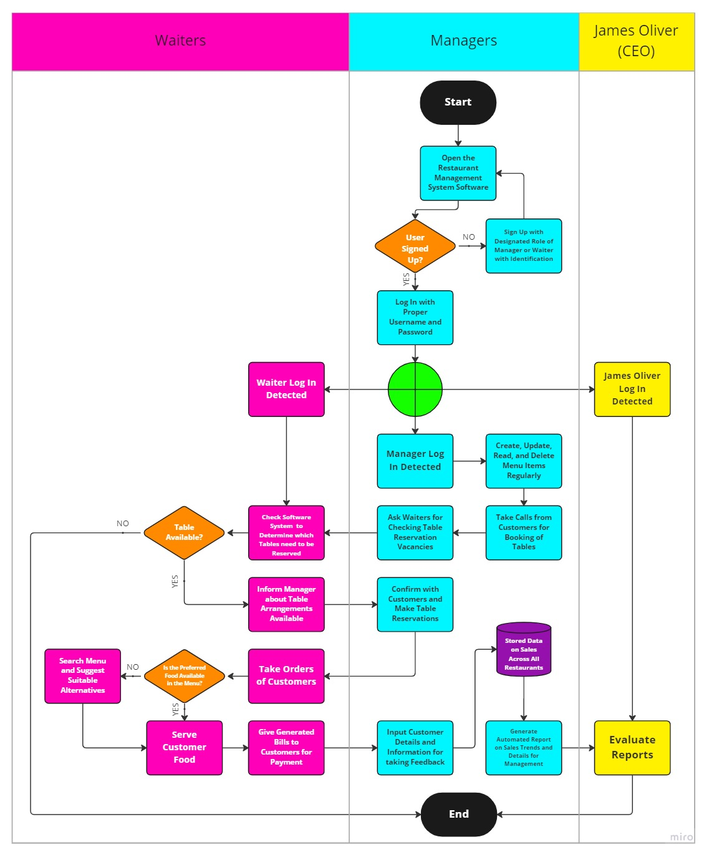

**Figure 6: Future State Flow Chart**

## 4. Scope of the Restaurant Management Software

The scope of the Restaurant Management System for ‘The Grill House’ can be illustrated using the context diagram:

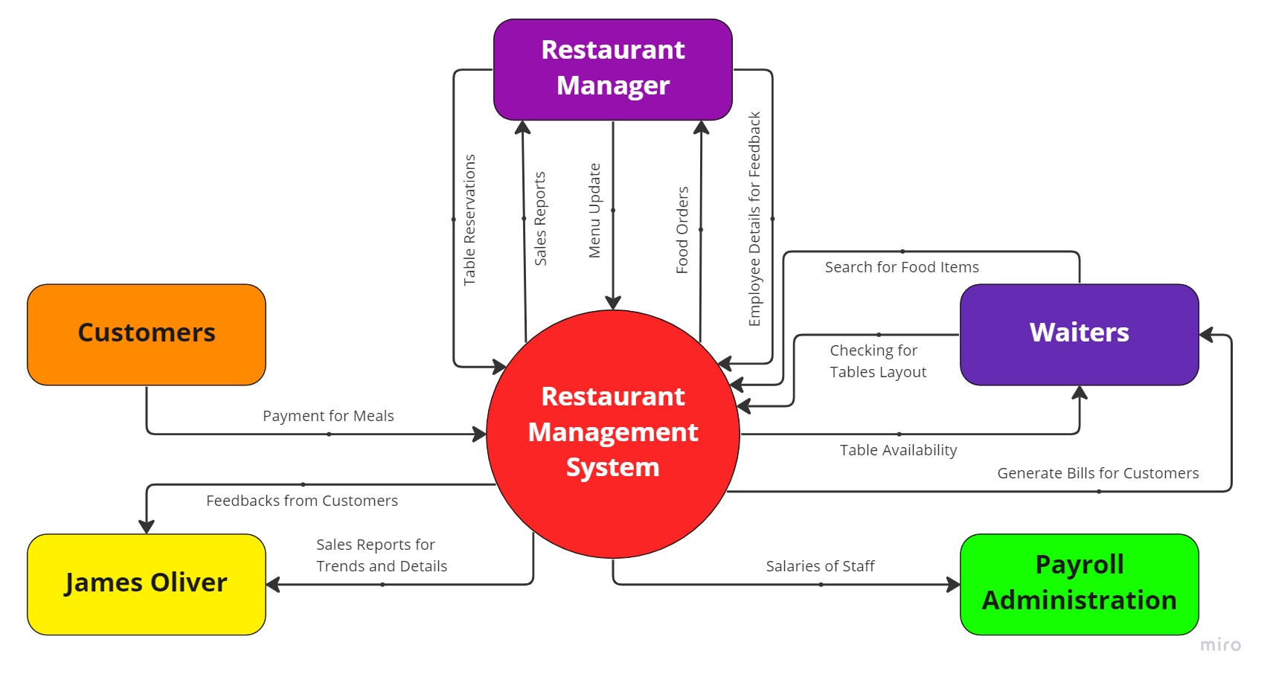

**Figure 7: Context Diagram of Restaurant Management System**

## 5. Main Features to be developed

The main features that are needed to be developed for the Restaurant Management System for ‘The Grill House’ are:

1. Online website application as well as a mobile application (compatible with Android, iOS, and Windows Mobile OS) with a user-friendly interface to be developed.
2. Page for Login ID and Password for managers, waiters, and James Oliver to sign in.
3. Registration page for new managers and waiters in the restaurant to register themselves in the system.
4. Change password facility to help the users change their passwords if needed.
5. Ability to restrict access and functions for managers, waiters, and James Oliver.
6. Allow managers to create, edit, update, and delete menu items with price every day.
7. Allow managers and waiters to search the menu using search facility option in the system.
8. Allow waiters to see the table layouts for table availability in the restaurant.
9. Allow waiters to automatically take orders and generate bills for the customers.
10. Allow managers to book and reserve tables for the customers.
11. Generate automated reports for management at the end of day regarding different sales value and dishes.
12. Allow payment gateway for customers to pay by cash or card.
13. Input feedback from the customers with full details.
14. Allow James Oliver access to see the reports for trends and details as well as feedbacks from customers to take suitable actions.

## 6. In-Scope and Out-of-Scope Items

The in-scope items and the out-of-scope items for the Restaurant Management System for ‘The Grill House’ are:

|  |  |
| --- | --- |
| In-Scope | Out-of-Scope |
| 1. Online Website and Mobile Application | 1. **Tips for Waiters** |
| 1. Login, Change Password, and Registration for Managers, Waiters, and James Oliver | 1. **Vendor management and supplier details** |
| 1. Food Menu and Special Offers | 1. **Chef/kitchen management** |
| 1. Feedback System | 1. **Inventory for food ingredients** |
| 1. Menu Search System | 1. **Home deliveries** |
| 1. Payment Security and Options |  |
| 1. Report Generation |  |
| 1. Table Layout Viewing |  |
| 1. Order Taking |  |
| 1. Automated Bill Generation |  |
| 1. Salaries for Staff |  |

**Table 4: In-Scope and Out-of-Scope Items**

## 7. Requirements of the Business

The functional and non-functional requirements of the Restaurant Management System for ‘The Grill House’ are:

### 7.1 Functional Requirements

1. Users should be able to register using their email ID.
2. Users should be able to log in using their ID and password.
3. Users should be able to change their password.
4. The manager should be able to create, edit, and update menu items every day.
5. Payroll Administration should be able to gather sales data for salaries and incentives.
6. Managers should be able to input feedback details and customer information in feedback forms.
7. Managers and waiters should be able to search menu items.
8. Managers should be able to make reservations for customers.
9. Waiters should be able to look at table layout for occupancy and seating arrangements.
10. Waiters should be able to take orders and generate automated bills for customers.
11. The system should be able to generate relevant reports on sales for trends and details.

### 7.2 Non-Functional Requirements

1. **Availability:** The system should be accessible during the working hours of the restaurant for the waiters and 24x7 for the managers and for James Oliver.
2. **Compatibility:** The system should be compatible with the management and payroll administration process of the company.
3. **Functionality:** The system should be able to provide a simple and friendly graphic user interface for ease of usage by the users and capable of meeting the needs of the external stakeholders.
4. **Maintainability:** The system should be developed with Java program and which will help to make it easy to modify and improve it.
5. **Reliability:** The system should be reliable to perform its functions and work 24 hours nonstop without issues, bugs, glitches, or data errors.
6. **Scalability:** The system should be able to handle orders from multiple people at the same time.
7. **Security:** The system should be secured enough for the payment gateway and prevent hacking.
8. **Usability:** The system should be user-friendly and easy to navigate.

## 8. Mock Screens for the Restaurant Management Software

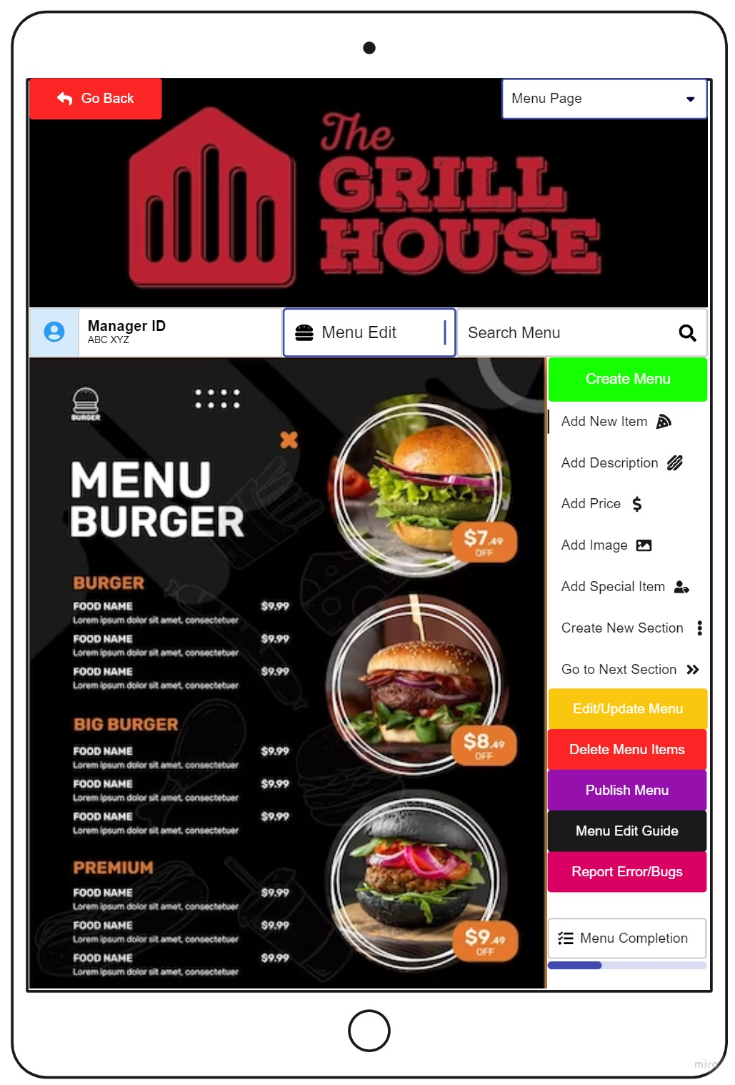

**Figure 12: Restaurant Management System Menu Creation**

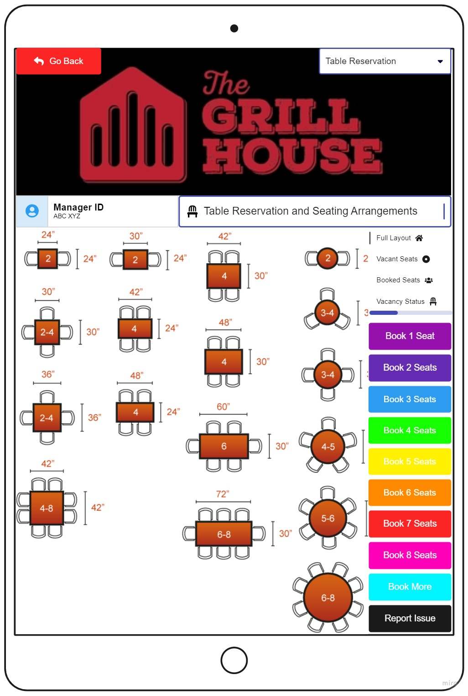

**Figure 13: Restaurant Management System Table Reservation**

# Week 3 – Tableau & Excel

## 1. Tableau

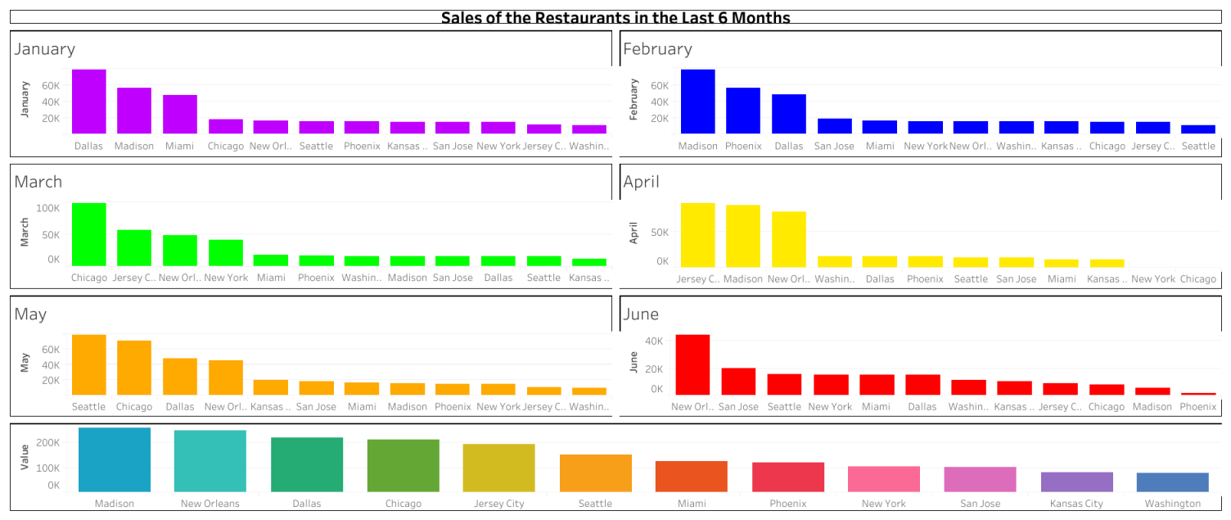

**Figure 14: Dashboard for Sales of Restaurants in the Last 6 Months**

(Source: <https://public.tableau.com/views/Capstone_16773433532240/RestaurantSales?:language=en-US&publish=yes&:display_count=n&:origin=viz_share_link>)

The above dashboard showcases the sales of the restaurants across USA in the past 6 months from January to June. As per the data, it has been found that in the past 6 months, the restaurant in Madison have generated the most sales, followed by New Orleans, Dallas, Chicago, and Jersey City as the top 5 highest selling restaurants of ‘The Grill House’.

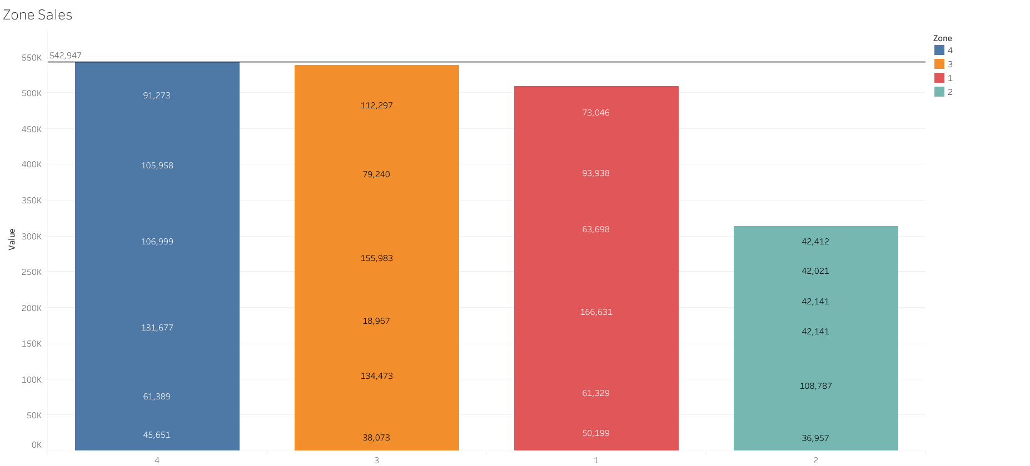

**Figure 15: Dashboard for Zone with the Highest Sales in the Last 6 Months**

(Source: <https://public.tableau.com/views/CapstonePart2/ZoneSales?:language=en-US&publish=yes&:display_count=n&:origin=viz_share_link>)

The above dashboard showcases the sales of each zone across USA in the past 6 months from January to June. As per the data, it has been found that in the past 6 months, Zone 4 has been the highest selling Zone with a total sale of $542,947, followed closely by Zone 3 which is followed by Zone 1, and finally, the least sales generating zone, Zone 2.

## 2. Excel

### 2.1 Question 1

**Figure 16: Zone with the Highest Sales in the Last 6 Months**

The above bar graph diagram showcases the sales of the restaurants in San Jose, Madison, and New York from the given dataset from January to June. It can be observed from the chart that the highest sale was recorded in Madison during April while the lowest sale was recorded in New York in April.

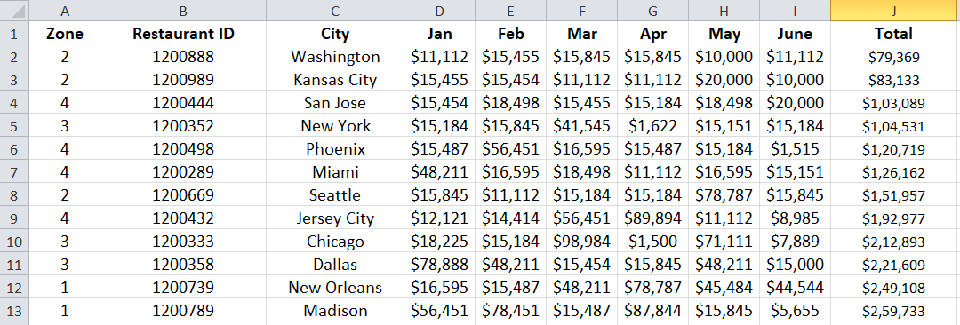

**Figure 17: Ascending Order of the Dataset**

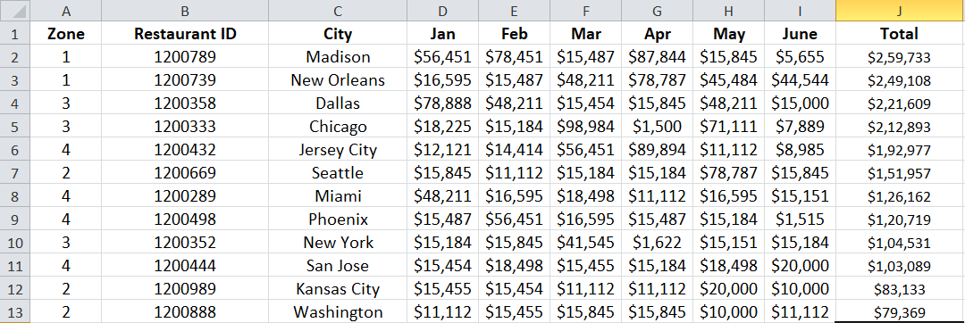

**Figure 18: Descending Order of the Dataset**

The above screenshots are the Ascending and Descending Order of the given dataset for the sales of restaurants in different cities from January to June. It has been found that Washington is the lowest sales generating city for ‘The Grill House’ restaurant chain while Madison is the highest sales generating city for the restaurant chain.

### 2.2 Question 2

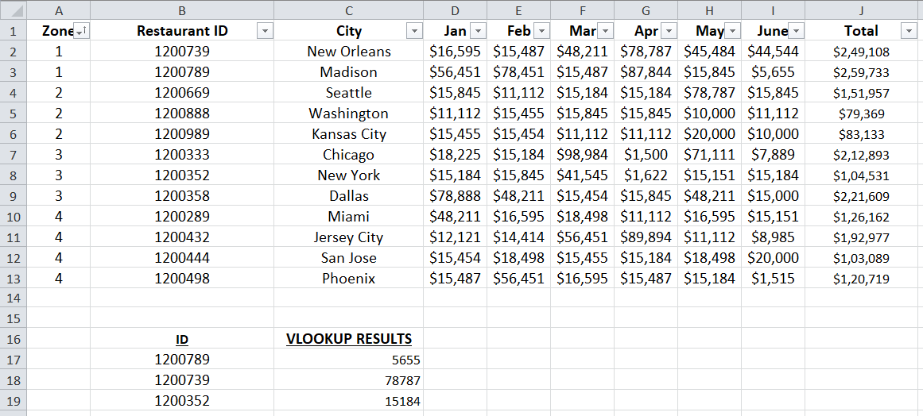

**Figure 19: VLOOKUP Results for given IDs**

The VLOOKUP formulas for the given IDs in the dataset when performed in the excel sheet in the above-diagram are:

1. 1200789 is **=VLOOKUP(B17,B2:I13,8,FALSE)**
2. 1200739 is **=VLOOKUP(B18,B2:I13,6,FALSE)**
3. 1200352 is **=VLOOKUP(B19,B3:I14,3,FALSE)**